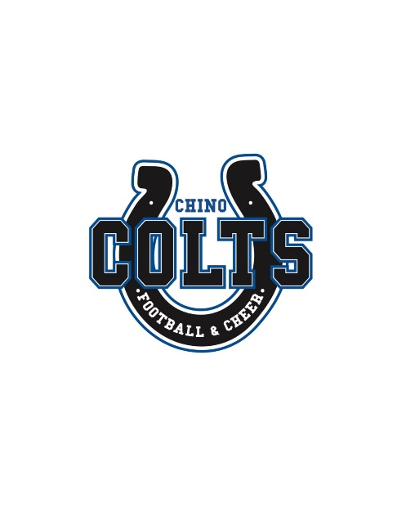

Chino Pop Warner Football and Cheerleading
PO Box 1057 Chino Ca. 91708
Tax ID# 93-4795181
Chino Pop Warner Sponsorships and Donations
Chino Pop Warner Little Scholars is a non-profit youth organization with over 250 local Football and Cheer participants (ages 3–15). Since 1968, we’ve proudly provided a safe, structured environment that builds confidence through sports and education. Our program is 100% run by community volunteers.

Your tax-deductible sponsorship helps us cover critical costs like equipment, uniforms, field rentals, insurance, and competition fees. More importantly, it helps build pride, teamwork, and leadership in our youth.

In-season support is needed for fees such as Uniform Costs/Warm-up or Jackets, Bowl games/Cheer Competition Costs, Referee and EMT Fees, Field Usage Fees / Insurance Fees, Conference Dues and team fees etc.
All sponsorships for our League, teams, or athletes are greatly appreciated and much needed.

Sponsor Information

Business/Individual Sponsor Name: _________________________________________________________
Business Website: _______________________________________________________________________
Email: ___________________________________________ Phone: _______________________________
Sponsor for: ☐ League
☐ Team - Name of team: _______________________________________________________
☐ Individual - Name of Athlete: ___________________________Amt $_________________
Place an ‘X’ in one of the boxes below to indicate the level of sponsorship you would like to provide.
.
Level | Donation | Benefits for League or Team Sponsorships
Platinum | $2,500+ | - Business/Family name AND LOGO displayed on the League Sponsor Banner hung at every Home Game (Banner must be provided by business/family)  - Business/Family name posted on our social media/website as a sponsor  - Company Website linked on our Website Sponsor Page  - End of season sponsor plaque
Gold | $1,000 | - Business/Family name AND LOGO displayed on the League Sponsor Banner hung at every Home Game (Banner must be provided by business/family)  - Recognition on social media & website  - End of season sponsor plaque
Silver | $500 | - Business/Family name posted on our social media/website as a sponsor  - End of season sponsor plaque
Bronze | $________ Custom amount | - Certificate of appreciation  We welcome donations of any size, thank you!
Please make checks payable to: Chino Pop Warner
Mail completed forms with payment to:
Chino Pop Warner
P.O. Box 1057
Chino, CA 91708

THANK YOU FOR YOUR GENEROUS SUPPORT!
You’re not just sponsoring a team; you’re investing in the future of our youth and community.
WWW.CHINOPOPWARNER.ORG

